Waterfall and Agile Models

The **Waterfall Model** is a design process that starts from high to low in a design phase, it steadily flows downwards in the steps that you need to take. The phases in a Waterfall Model are the phases of Conception, Initiation, Analysis, Design, Construction, Testing, Production/Implementation, and Maintenance, each consists of different series of tasks and has different objectives. The waterfall model is the pioneer of the SDLC process

The waterfall model is used as a logical progression of steps in a design process.In waterfall, one of the earliest SDLC approaches that are used for software development each phase must be completed before another is started because the phases can not overlap and therefore they must be finished or you can’t progress to the next step in the waterfall model.

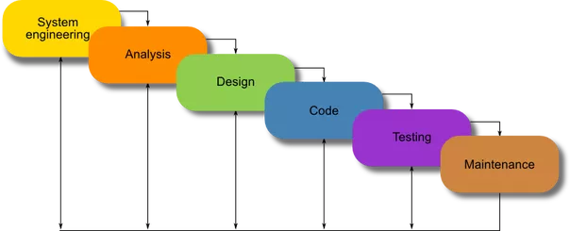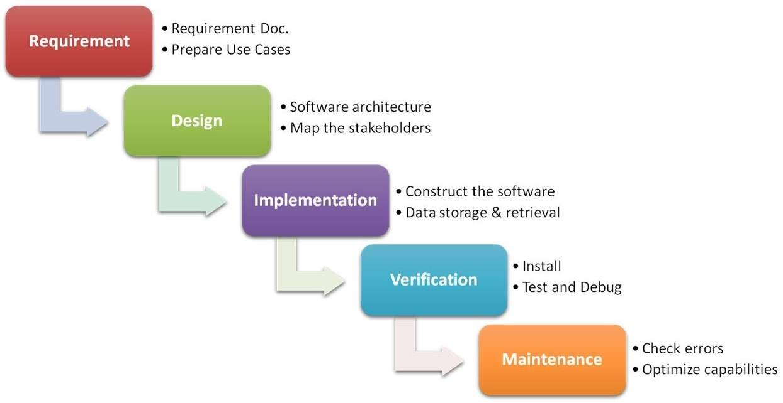

The **Agile Model** is a combo of process models that focus on adaptability and customer satisfaction by constant and rapid delivery of software products. The Agile model method breaks the product into small pieces/builds, these builds are provided in iterations. Each iteration can last from 1-3 weeks.

Each iteration involves cross functioning teams working together on various areas such as:

* Requirements Analysis
* Design
* Coding
* Unit Testing and
* Acceptance Testing
* Planning

At the end of the iteration the product is finished and therefore it will be presented and displayed to the customers and important shareholders of the company/business.

